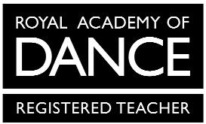
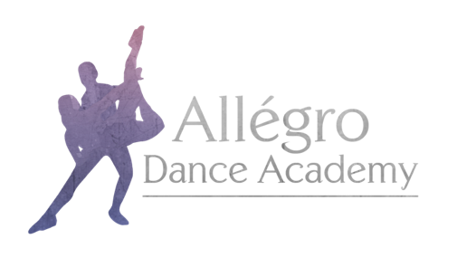

Allégro Dance Academy Uniform Order Form
Branded Items

Child’s Name:

Height:

Chest:

Item | Price | Size | Quantity
Allégro Dance Academy Hoodie in Pink | From £25.00
Allégro Dance Academy Hoodie in Black | From £25.00
Allégro Dance Academy Onesie in Black | From £32.00
Allégro Dance Academy T-Shirt in Black | From £12.00
Allégro Dance Academy Leggings in Black | From £18.00

Allégro Dance Academy hoodies and onesies have the option for personalisation on the back. If you would like your child’s name printed, please specify exactly what you would like printed here:

Sizes available:
Child – 3-4, 5-6, 7-8, 9-11, 12-13
Adult – Small, Medium, Large (Light pink hoodie unavailable in adult sizes)

Please email this completed form to uniform@allegro-dance-academy.co.uk

