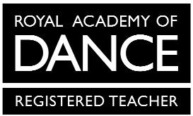
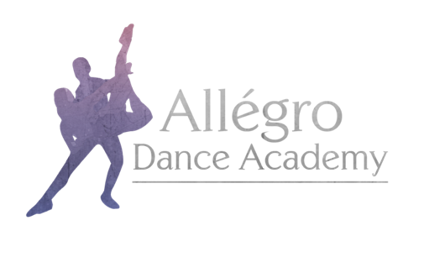

Allégro Dance Academy Uniform Order Form
Grade 4 & 5 Ballet

Child’s Name:

Height:

Waist:

Chest:

Waist – Mid Shin:

Outdoor Shoe Size:
Mandatory items are marked *
Item | Price | Size | Quantity
*Purple Regulation Leotard | From £20.00
*Bloch ‘Performa’ Ballet Shoes | £16.00
*Ballet Tights | £8.00
Ballet Cardigan in Purple | £16.00
*Black Character Skirt | £30.00
*Black Character Shoes | £21.00
Allégro Dance Academy Hoodie in Pink | From £25.00
Allégro Dance Academy Hoodie in Black | From £25.00
Allégro Dance Academy Onesie in Black | From £32.00

Allégro Dance Academy hoodies and onesies have the option for personalisation on the back. If you would like your child’s name printed, please specify exactly what you would like printed here:

When stating which size you require please use the size guide on the uniform section of the website for all items except hoodies and onesies.

The following sizes are available for hoodies and onesies:
Child – 3-4, 5-6, 7-8, 9-11, 12-13
Adult – Small, Medium Large

Please email your completed form to uniform@allegro-dance-academy.co.uk

