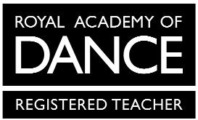
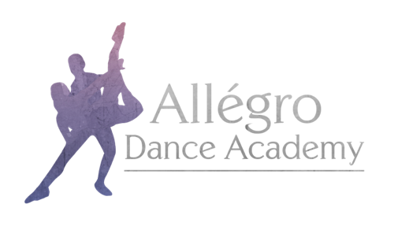

Allégro Dance Academy Uniform Order Form
Junior Tap

Child’s Name:

Height:

Chest:

Mandatory items are marked *
Item | Price | Size | Quantity
*Allégro Dance Academy T-Shirt in Black | From £12.00
*Allégro Dance Academy Leggings in Black | From £18.00
*Bloch Timestep Tap Shoes | From £20.00
Allégro Dance Academy Hoodie in Black | From 25.00
Allégro Dance Academy Hoodie in Pink | From £25.00

Allégro Dance Academy hoodies and onesies have the option for personalisation on the back. If you would like your child’s name printed, please specify exactly what you would like printed here:

Sizes available:
Child – 3-4, 5-6, 7-8, 9-11, 12-13

Please email this completed form to uniform@allegro-dance-academy.co.uk

