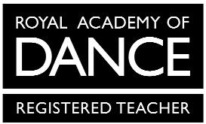
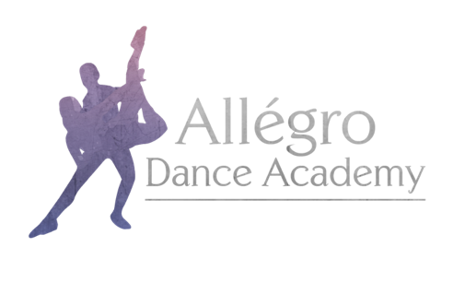

Allégro Dance Academy Uniform Order Form
Grade 2 & 3 Ballet

Child’s Name:

Height:

Waist:

Chest:

Waist – Mid Shin:

Outdoor Shoe Size:
Mandatory items are marked *
Item | Price | Size | Quantity
*Freed ‘Faith’ Leotard in Lavender | From £20.00
*Freed ‘Aspire’ Satin Shoes | From £12.00
*Ballet Tights (Convertible) | £9.00
Freed Cardigan in Lavender | From £17.00
*Black Character Skirt (must be ordered directly from ADA) | Prices Vary Dependent on Size
*Black Character Shoes | From £22.00 (G2)  From £24.00 (G3)
Black Character Shoe Bag with Matching Ribbons | £5.00
Allégro Dance Academy Hoodie in Pink | From £25.00
Allégro Dance Academy Hoodie in Black | From £25.00
Allégro Dance Academy Onesie in Black | From £32.00
Allégro Dance Academy hoodies and onesies have the option for personalisation on the back. If you would like your child’s name printed, please specify exactly what you would like printed here:

When stating which size you require please use the guide on the uniform section of the website for all items except hoodies and onesies.

The following sizes are available for hoodies and onesies:
Child – 3-4, 5-6, 7-8, 9-11, 12-13
Adult – Small, Medium Large
Please email your completed form to uniform@allegro-dance-academy.co.uk

