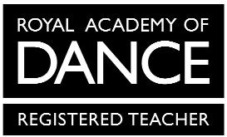
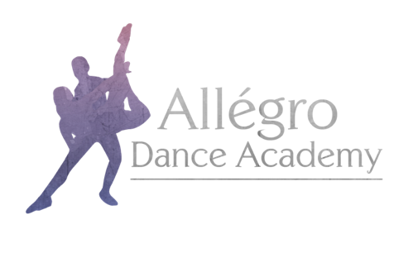

Allégro Dance Academy Uniform Order Form Nursery, Pre School, Pre Primary & Primary Ballet

Child’s Name:

Height:

Waist:

Chest:

Outdoor Shoe Size:
Mandatory items are marked *
Item | Price | Size | Quantity
*Freed T-Shirt in White | £16.00
*Canvas Ballet Shoes in White | From £10.00
*Ballet Socks in White | £4.00
*Freed Shorts in Black | £12.00
Allégro Dance Academy Hoodie in Pink | From £25.00
Allégro Dance Academy Hoodie in Black | From £25.00
Allégro Dance Academy Onesie in Black | From £32.00

Allégro Dance Academy hoodies and onesies have the option for personalisation on the back. If you would like your child’s name printed, please specify exactly what you would like printed here:

When stating which size you require please use the guide on the uniform section of the website for all items except hoodies and onesies.

The following sizes are available for hoodies and onesies:
Child – 3-4, 5-6, 7-8, 9-11, 12-13
Adult – Small, Medium Large

Please email your completed form to uniform@allegro-dance-academy.co.uk

