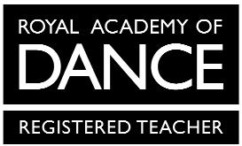
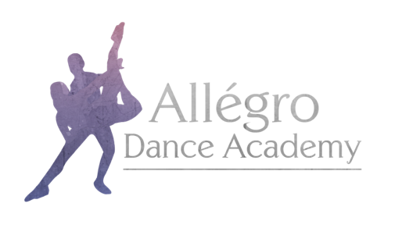

Allégro Dance Academy Uniform Order Form
Pre-Primary & Primary Ballet

Child’s Name:

Height:

Waist:

Chest:

Outdoor Shoe Size:
Mandatory items are marked *
Item | Price | Size | Quantity
*Freed ‘Chloe’ Leotard in Lilac | £16.00
*Freed ‘Chloe’ Skirt in Lilac | £16.00
*Freed ‘Aspire’ Satin Shoes in Pink | £12.00
*Freed Ballet Socks in Pink | £4.00
Freed Cardigan in Lilac | £16.00
Allégro Dance Academy Hoodie in Pink | From £25.00
Allégro Dance Academy Hoodie in Black | From £25.00
Allégro Dance Academy Onesie in Black | From £32.00
Hair Accessories in Lilac | From £1.50

Allégro Dance Academy hoodies and onesies have the option for personalisation on the back. If you would like your child’s name printed, please specify exactly what you would like printed here:

When stating which size you require please use the guide on the uniform section of the website for all items except hoodies and onesies.

The following sizes are available for hoodies and onesies:
Child – 3-4, 5-6, 7-8, 9-11, 12-13
Adult – Small, Medium Large

Please email your completed form to uniform@allegro-dance-academy.co.uk

